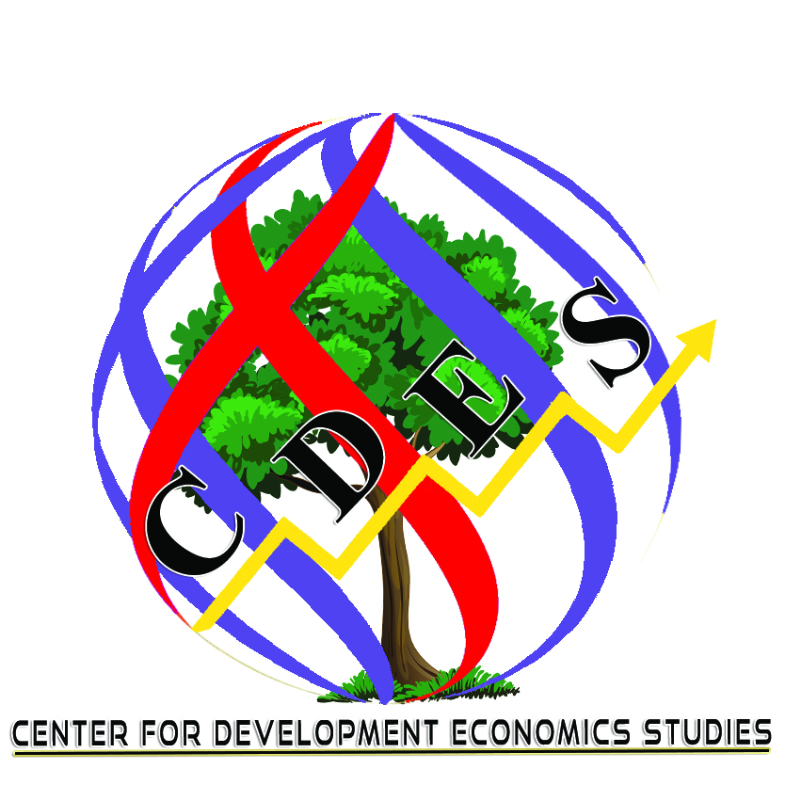

The Journal of Development Economics and Management Research Studies (JDMS)
Plot No: 144/1, Fifth Cross Street, Sadasivam Nagar, Madipakkam, Chennai-600 0091

COPYRIGHT AGREEMENT FORM

(The Author/Authors are requested to sign and Email the same to the publisher at info@cdes.org.in; stnavukkarasu@yhaoo.com)

Basic details of the Author/Authors

Name of the Journal:

Name/Names of Authors:

Institutional affiliation/University/College:

Title of the manuscript:

Number of pages of manuscript:

Contact phone no:

Complete address:

I / We hereby agree to publish our manuscript subject to the following requirements:

- That this manuscript submitted by me for publication in your Journal of Development Economics and Management Research Studies (JDMS) of Center for Development Economics Studies (CDES) has NOT been published in parts or full in some other publications viz., journal or magazine or newspaper in public or private circulation. And also affirm that this is my/our own original work.

- That Author/Authors hereby agree for publication in the JDMS and assign copyright as per the copyright Laws of the Government of India and international copyrights under Creative Commons Attribution-Noncommercial-Share Alike 4.0 Unported License to the CDES in the event of its publication.

- That Author/Authors hereby avow that the manuscript is fully comply with the copyright Laws without infringement, plagiarism, IPR, patent, ethical issues, conflict of interest, funding agency permission issues etc.

- That Author/Authors hereby agrees that the CDES is not violation of the copyright Laws and any infringement, plagiarism, IPR, patent, ethical issues, conflict of interest, funding agency permission, etc., if any such thing arises after publication and undertake to settle the same at my/our own expenses.

Signature of the Author with name and date:

Signature of the Second Author with name and date (if any):

Signature of the Third Author with name and date (if any):

Kindly visit our website for any details: http://www.cdes.org.in/about-journal/

***

